An Experience in Using Python

with Anaconda, Eclipse, Python2, Python3, GUI Programming

Ray Smith ([raysmith@alum.mit.edu](mailto:raysmith@alum.mit.edu))

April 25, 2018

# Introduction

Python, while not the only programming language in use today, is a rather popular and powerful tool. My goal today is to present my latest experience, using Python and some other useful tools, giving the audience some incite in to their use. All of these tools are worthy of talks, books, or courses on themselves. My plan is to touch on each, exposing some benefits, including some pointers affording individuals the choice of proceeding further investigation as they may see fit.

Ray Smith (Charles Raymond Smith)

* Decades of Programming – engineering, scientific, financial
* Programming environments – embedded, application, systems
* Languages – C, C++, Perl, Java, Python, Assembly, shell, Fortran, PL1, …
* Currently investigating graphics / game programming

An Example – fileFind – a file text pattern matcher

* Windows GUI version of Unix/Linux’s **find**
* Reduced function but too simple
* Work in progress
* <https://github.com/raysmith619/findFile/>
* 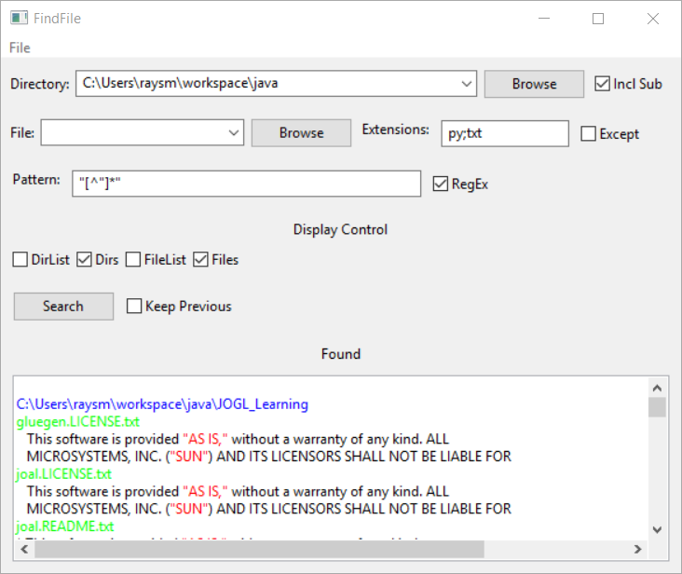

findFile.py Screen Shot

* Features – so far
  + Directory/File Searching
  + Subdirectory search
  + Multiple file extensions
  + Regular expression text patterns
  + Colorized text accents
  + Directory / File setting history
  + Settings restored between program runs
* Features contemplated
  + Easier
    - Multiple patterns
    - Listing multiple occurrences within a line
    - Multiline patterns
    - Output formatting with match patterns
  + Less so
    - Additional file types e.g. MsWord, MsExcell
    - Searching search results

Python – Programming language

* popular programming language in wide use
* Used in Data Analytics
* Used as introduction to programming at MIT

Python2, Python3

* Two dialects of the Python Language
* Independent lines – 2.x, 3.x
* Python2.x – lots of legacy code, faster?...
* Python3.x – the future?, language improvements
* Python2.x – print “Hi..”, except Exception, e:
* Python3.x – print(“Hi…), except Exception as e:
* https://www.digitalocean.com/community/tutorials/how-to-port-python-2-code-to-python-3
* http://python-future.org/overview.html

Anaconda – Installation / Development System

* <https://www.anaconda.com/what-is-anaconda/>
* “With over 6 million users, the open source [Anaconda Distribution](https://www.anaconda.com/distribution/) is the easiest way to do Python data science and machine learning. It includes 250+ popular data science packages and the *conda* package and virtual environment manager for Windows, Linux, and MacOS. …
* High-Performance Distribution
* Package Management
* Python 3.6 version
* Python 2.7 version

https://docs.anaconda.com/anaconda/install/windows

Eclipse – Graphical User Interface (GUI)

* Development Platform for Java, Python, Perl
* Multi-language
* Debugger

GUI Programming

* The world is *GRAPHICAL*
* Similar but different across OS / Language
* We are trying out wxPython
* We have used others, e.g Tkinter
* Too much to do from scratch